微信公众号支付学费指南
微信添加朋友搜索微信公众号：昆明医科大学财务处，搜索之后关注该公众号。

学生登录 ：
学生用户名：学号
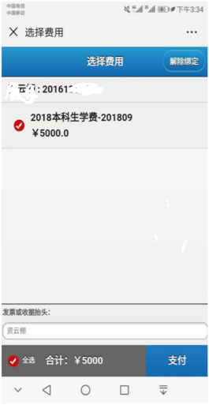
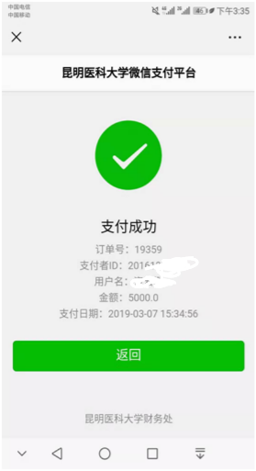
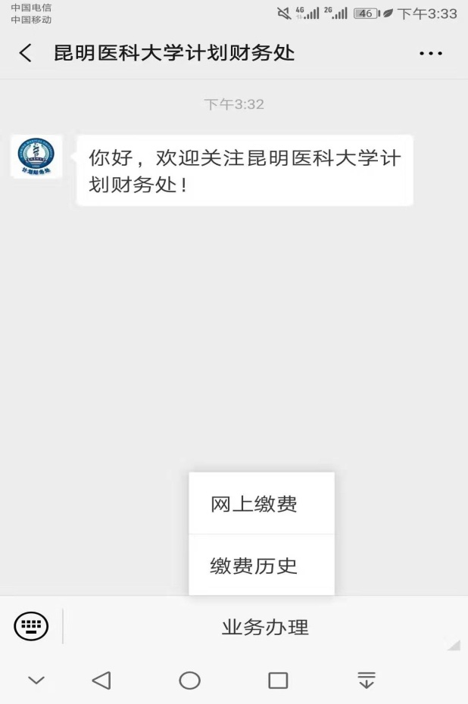
初始密码：见2022级研究生录取通知书中的《入学须知》
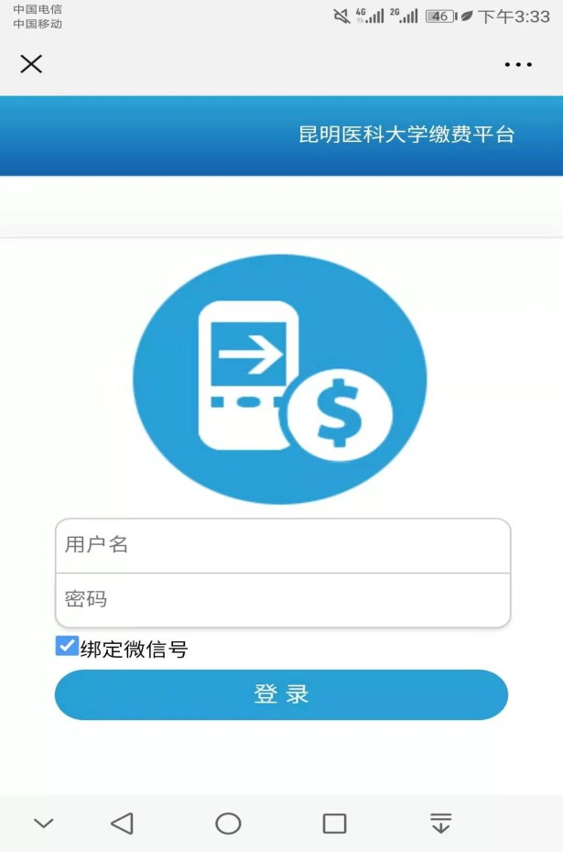

核对本人姓名、学号、金额，进入支付页面进行缴费即可，支付成功后由学院统一发放学费收据。

Guide for FeesPayment throughWeChat
How to use it?
STEP 1: Search the official account昆明医私大学财务处(kunmingyike da xue ji huacaiwuchu) on We Chat and folow it.
STEP2 :Press the button业务办理at the bottom of the screen and choose网上缴费
STEP 3: Input your students number as用户名(user' s name) and密码( password)
STEP 4: Now you can check howmuch money you still need to pay. Ifthe information is correct, tick the items and press the blue button支付(pay) at the lower right corner.
STEP 5: If you pay successfully, it will show支付成功。 Now you cantake a screenshot as evidence, andthe receipt will be given by yourcoordinator later. If you fail to pay, please contact with your coordinator.

