微信公众号支付学费指南
微信添加朋友搜索微信公众号：昆明医科大学计划财务处，搜索之后关注该公众号。

学生登录 ：
学生用户名：学号
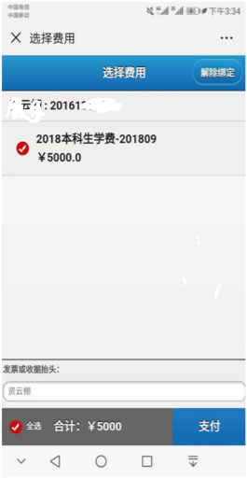
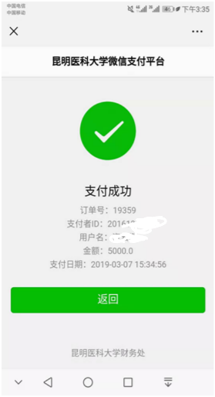
初始密码：身份证后六位（X大写）或者学号
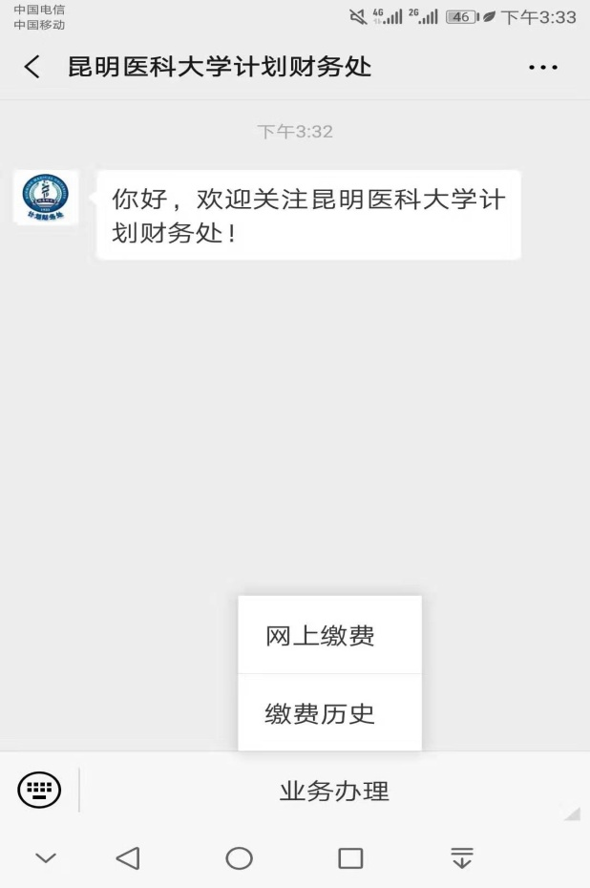
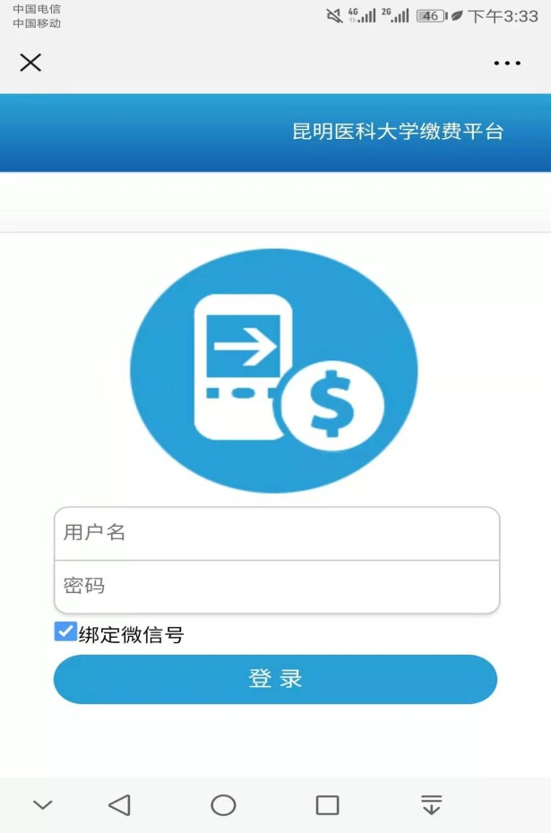

核对本人姓名、学号、金额，进入支付页面进行缴费即可，支付成功后由学院统一发放学费收据。

Guide for Fees Payment through WeChat
How to use it?
STEP 1: Search the official account昆明医私大学计划财务处(kun ming yi ke da xue ji hua cai wu chu) on We Chat and folow it.
STEP2 :Press the button业务办理at the bottom of the screen and choose网上缴费
STEP 3: Input your students number as用户名(user' s name) and密码( password)
STEP 4: Now you can check how much money you still need to pay. Ifthe information is correct, tick the items and press the blue button支付(pay) at the lower right corner.
STEP 5: If you pay successfully, it will show支付成功。 Now you can take a screenshot as evidence, and the receipt will be given by your coordinator later. If you fail to pay, please contact with your coordinator.

